31. Predation, Competition, and Spacing *(Chapters 52, 53)*

______________________________________________________________________________

### I. Predation *(1242-1243, 1252-1255)*

A. Rationale and Form of the Model

B. Graphical Representation

1. The interaction

2. Production of population cycles

# C. Predator Regulation of Prey Populations

1. Prey population size

2. Prey population composition

D. Applications for Pest Control

1. Examples

2. Population consequences of pesticide use

II. Competition *(1255-1257)*

A. Definitions

1. Competition

2. Limiting resources

3. Exploitative competition

4. Interference competition

B. Intraspecific Competition

1. Population density and logistic growth

2. Data from single‑species lab cultures

C. Interspecific Competition

1. Lab experiments on interspecific competition

2. The competitive exclusion principle

3. Indirect field evidence: resource partitioning and character displacement

4. Direct field evidence: addition and removal experiments

III. Spacing in Animals *(1224-1225)*

A. Intensity of Intraspecific Competition

B. Patterns of Dispersion

C. Individual Distance

# D. Territories of Animals

1. Definition of territory

2. Environmental requisites for territoriality

3. Functions of territoriality

4. Consequences of territoriality

5. Seasonality of territory ownership

31-1

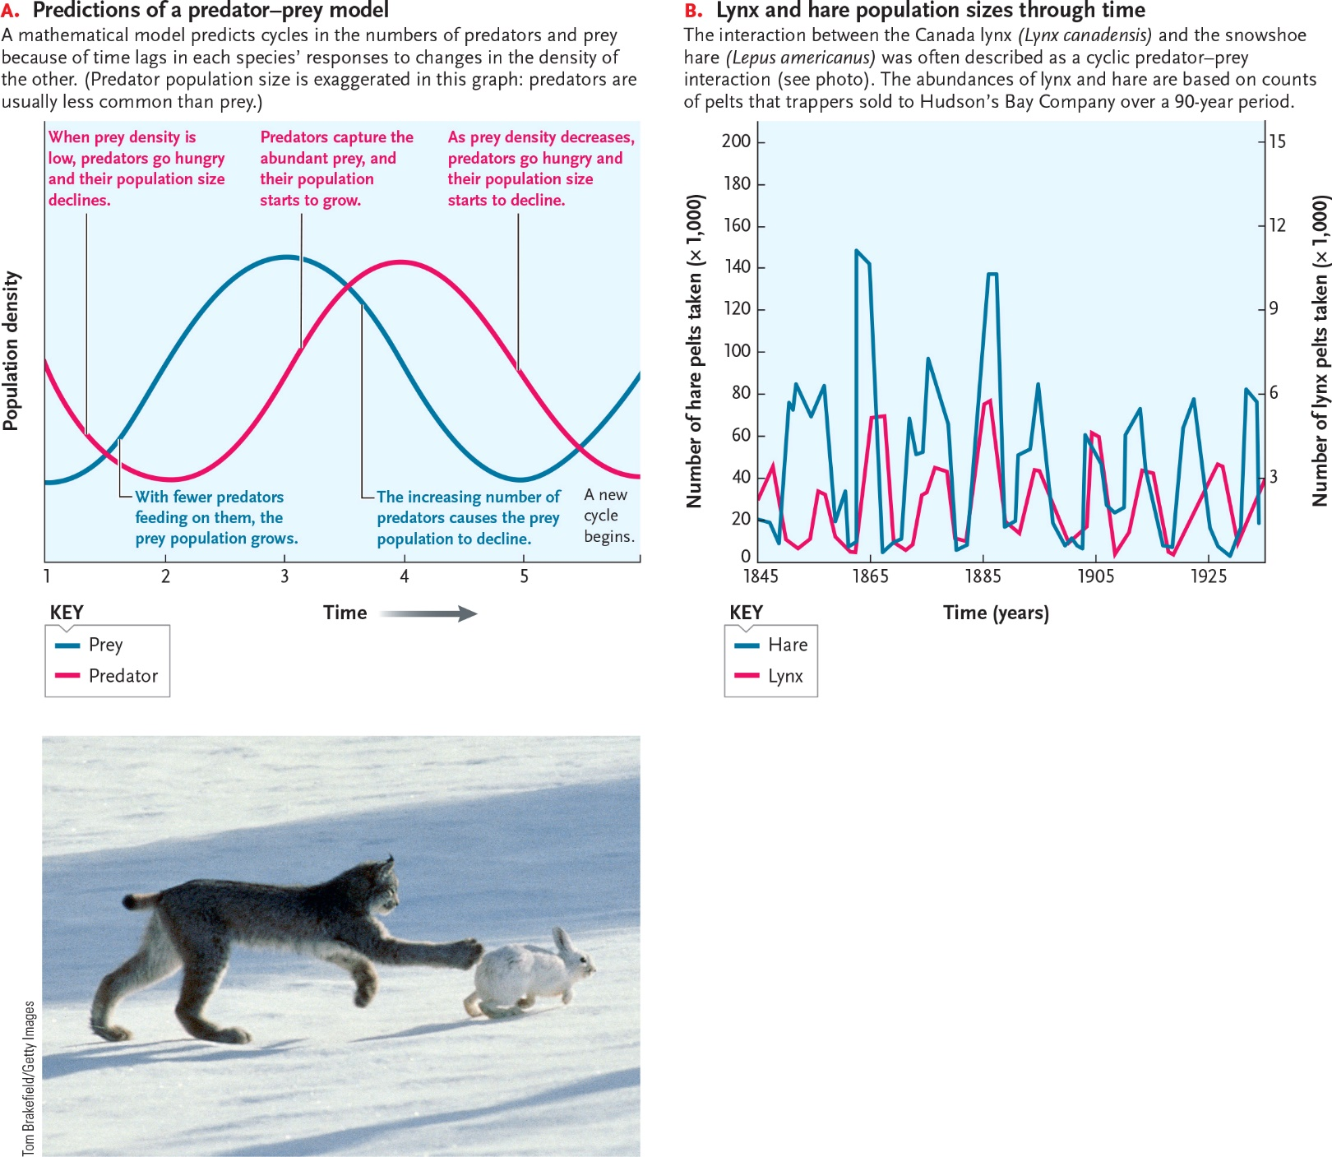

31-2

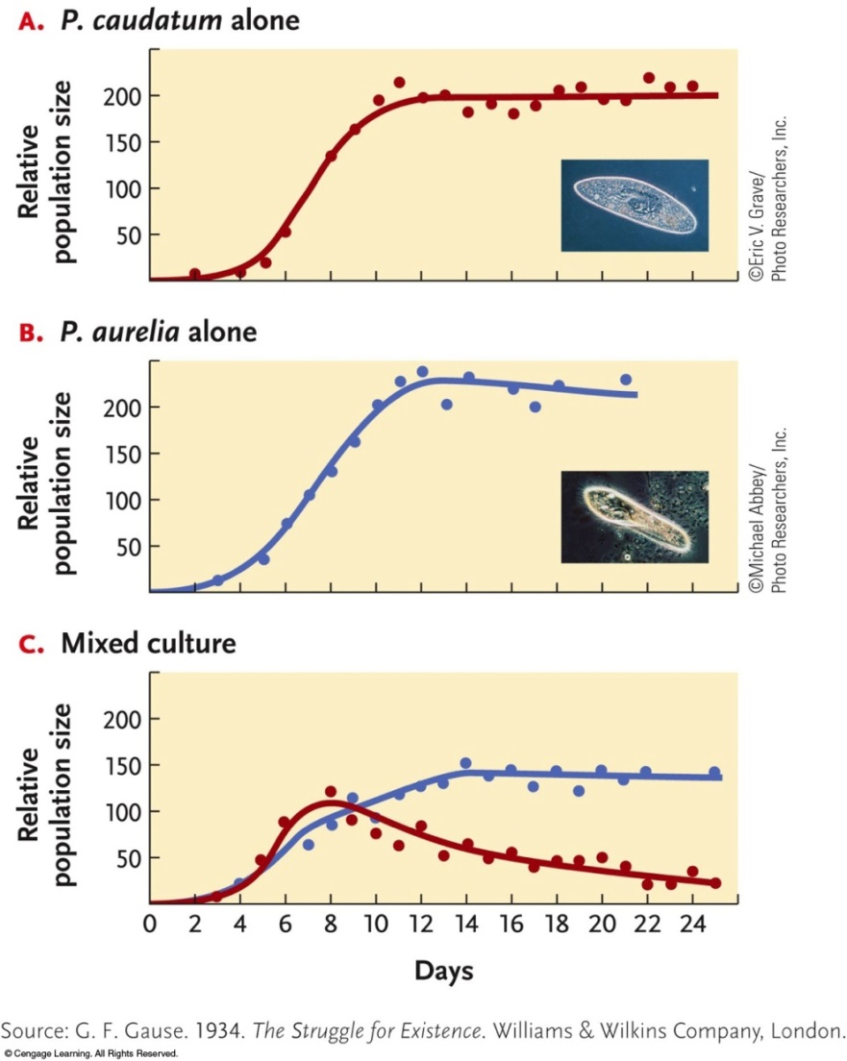

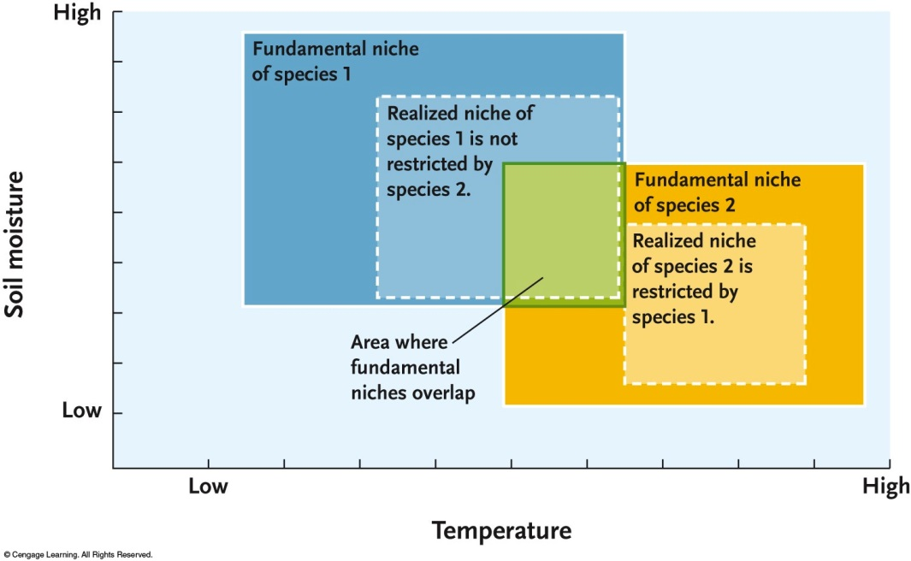

31-3

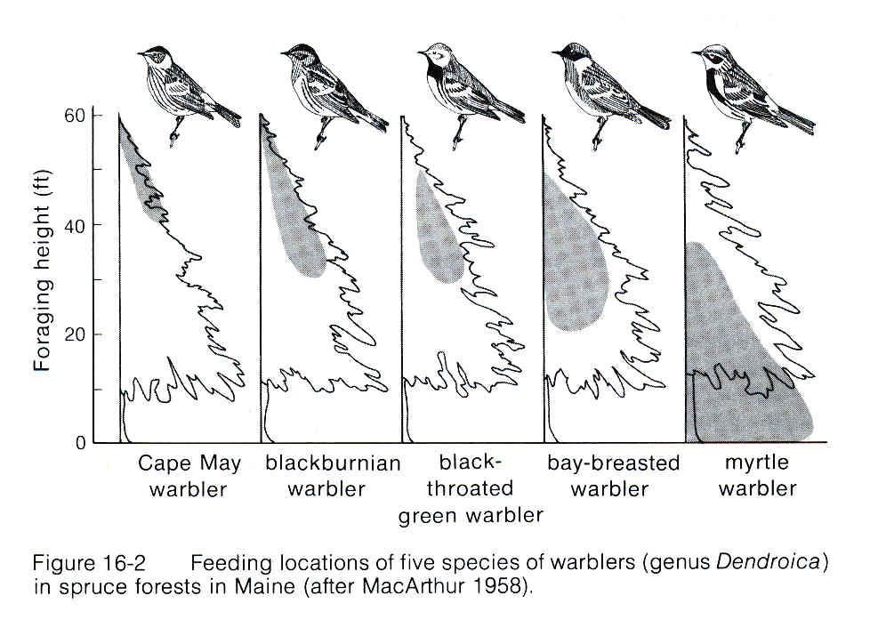

**______________________________________________________________________________**

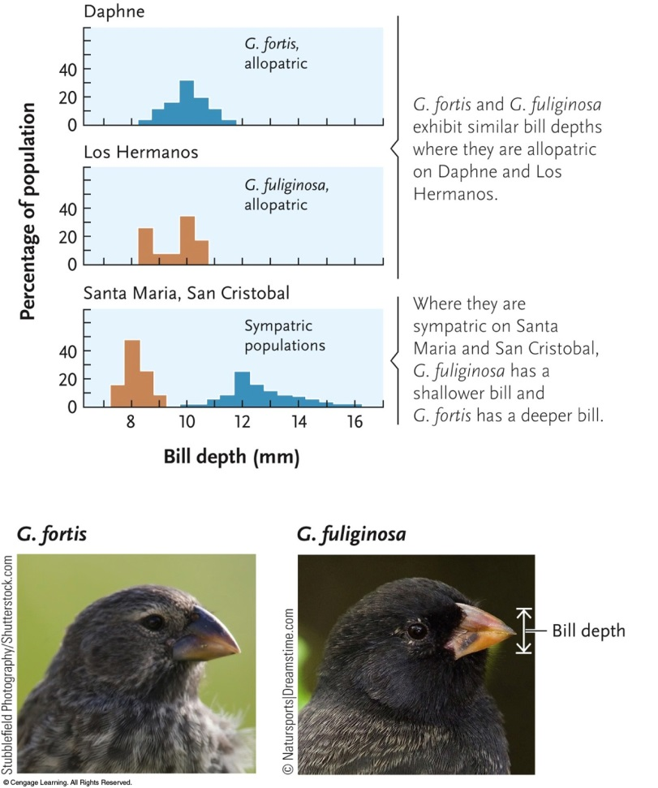

31-4

